Kickstarter Data Analysis

Amit Malik

# Highlights

* 59% of campaigns on Kickstarter are successful.
* Campaigns with higher goals are less likely to successful
* Tech Hardware and Table top games have best outperformed their goals!
* Most projects are for 1 month. Next most common duration is 2 months.
* USA residents fund the most projects (78% of the $)

# Key Conclusions

## Campaigns with lower goals tend to be more successful

The natural trend seen is that lower goals tend to be more successful. A regression analysis shows a good co-relation between the Goal amount and the success rate



## Music/Theatre are the most successful category

Music is the most successful category (82%), followed by Theatre, Film & Video and Technology and together account for 78% of all the campaigns on Kickstarter. With 1066 projects, Plays are the highest sub-category and have >50% success. Techology sees the highest average donation



Graph below show the Average donation amount per category and the # of funded projects

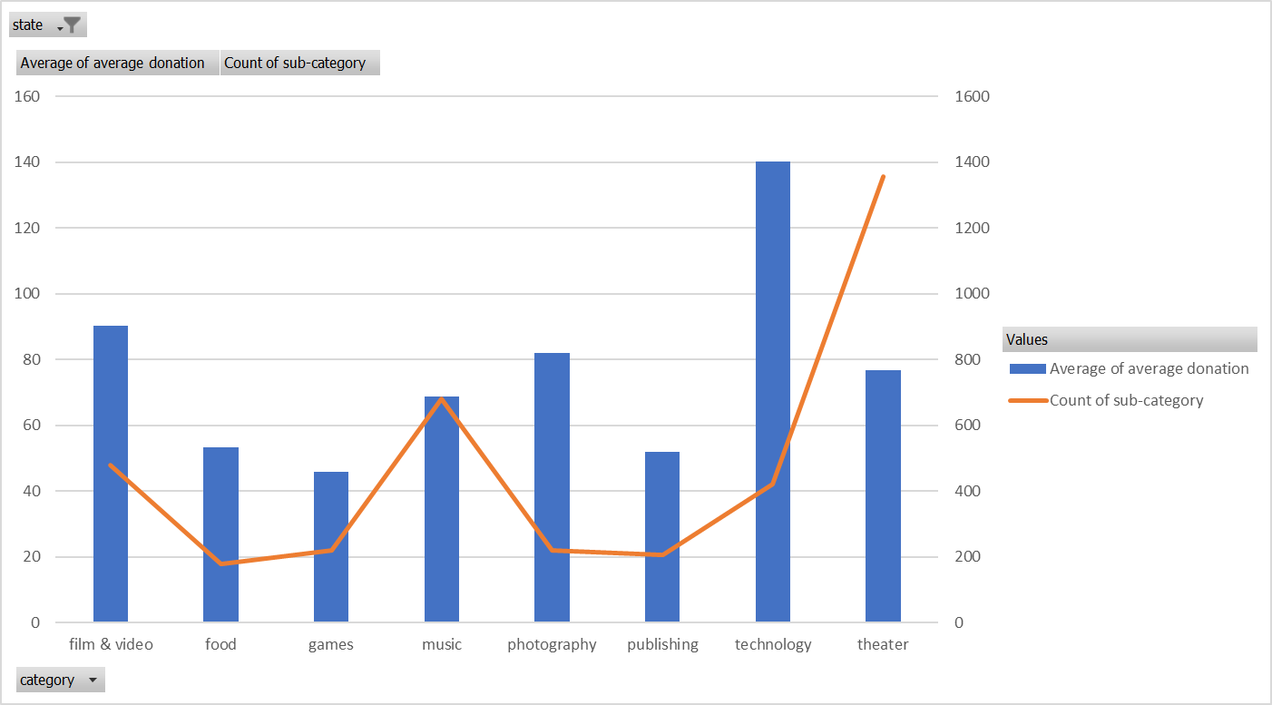

## Start right to end right

Feb-May are the best times to start a campaign. Avoid Dec! Most patrons are from USA and probably spending their $ on gifts and vacations!

Surprise: Projects started in Nov see a spike in success, you can’t wait till the period of Feb-May, target Nov.



# Some Limitations

* The dataset shows a drastic difference to the 33% success ratio published vs 59% seen in the dataset
* The dataset only represents <1.5% (4000/300,000) of all projects and a larger dataset might be needed to create a more accurate analysis
* The data is out dated and no data is available after March 2017 and most data is from 2015. Current trends might be different than the data set that has been provided
* The data could be misleading since smaller projects are more often supported by patrons who know the campaigner rather than the product/service being funded.

# Additional Plots

* Added to report